QRG - 1W Review Rail Data WAIO (Email)

# Overview

This is a QRG for a script which automates the process of extracting rake data from [RVC](https://rsb.bhp.com/rvc) (specifically Cycle Points and Car Counts), to forward to the HLO and/or MTM team(s) for data correction. It is one half of the SAP PM02 **1W Review Rail Data WAIO** for TROC (the other half being rail [consist corrections](https://bhp.service-now.com/now/nav/ui/classic/params/target/kb_view.do%3Fsysparm_article%3DKB0068520))

This process may change in the future, but is correct as of writing this document (15/01/2025)  
  
Please see the following email for clarifications: 

# Steps

1. Make sure the script is placed (and run) from a **local directory**  
   (i.e. Desktop, Downloads, Documents etc. **not %appdata%** or **OneDrive**)  
   *Note: I’m not sure why, but the script has weird permission issues in other directories*
2. Launch the script  
   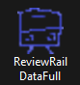
3. After a short delay, a terminal window should appear, followed by a dialog prompt to confirm execution.  
     
   (NOTE: If you cannot see the pop-up dialogue, it may be hidden by another appliaction – check your current active windows using **ALT+TAB** and bring it into focus)  
   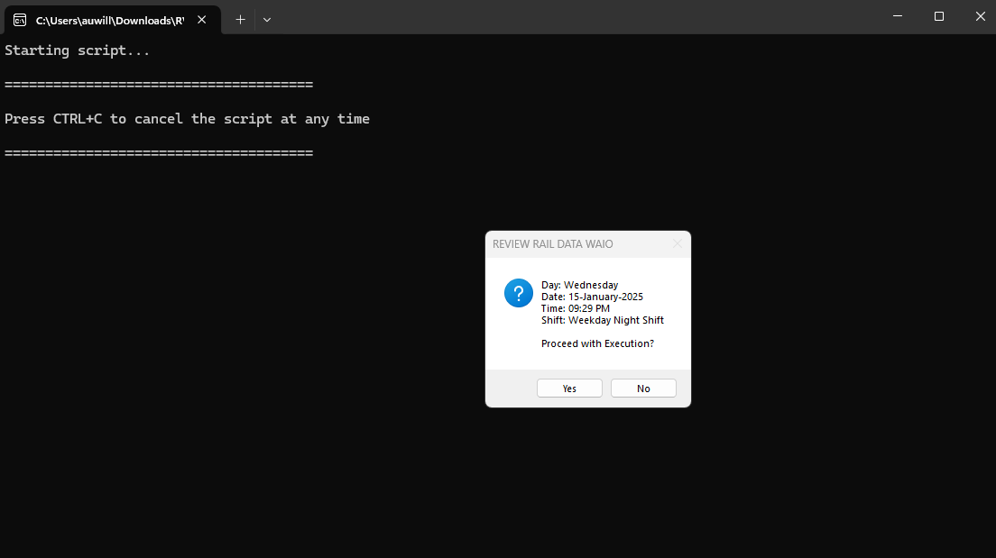  
   Select **Yes**
4. The next step wilil be to download of the rake data from [RVC](https://rsb.bhp.com/rvc).  
   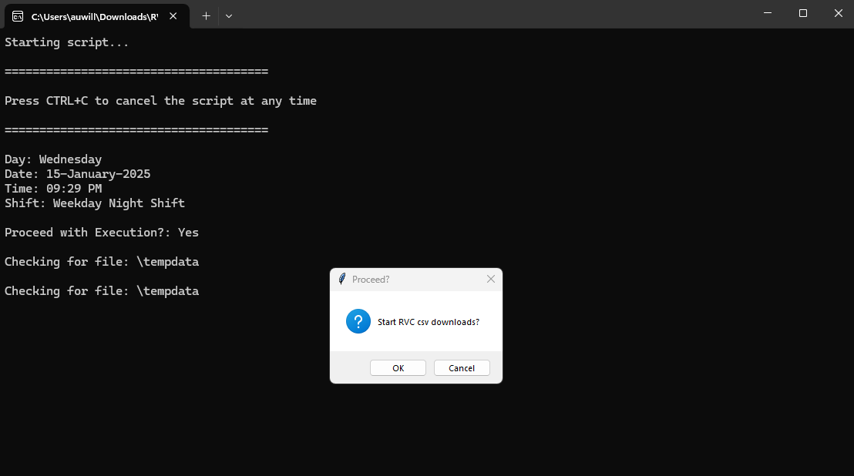  
   Select **OK**
5. Once downloaded successfully, a popup will appear to confirm this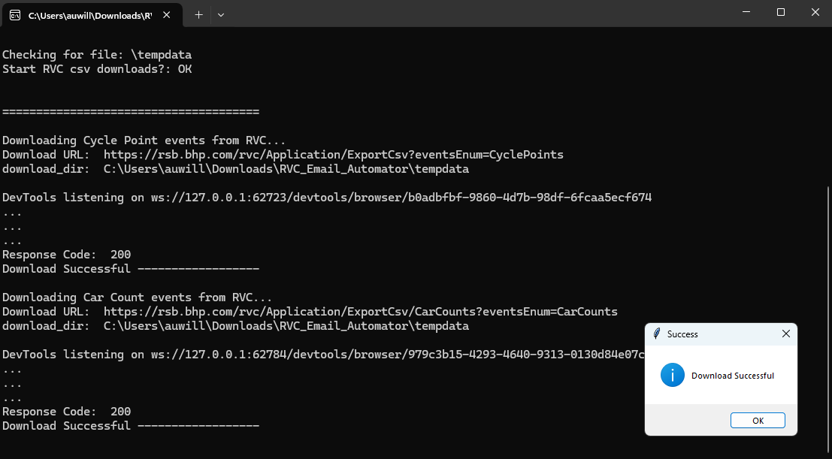  
   Select **OK**
6. Two more prompts will appear, one after the other.
   1. The first prompt will be to **remove any rows that contain notes**A screenshot of a computer

      Description automatically generatedSelect **Yes**
   2. The second prompt will be to **remove the Notes column itself**  
      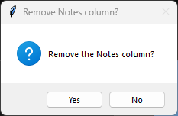Select **Yes**
7. An email draft will pop-up with information filled out for you.   
     
   Feel free to edit or format it to your own preference, then **send the email** :) 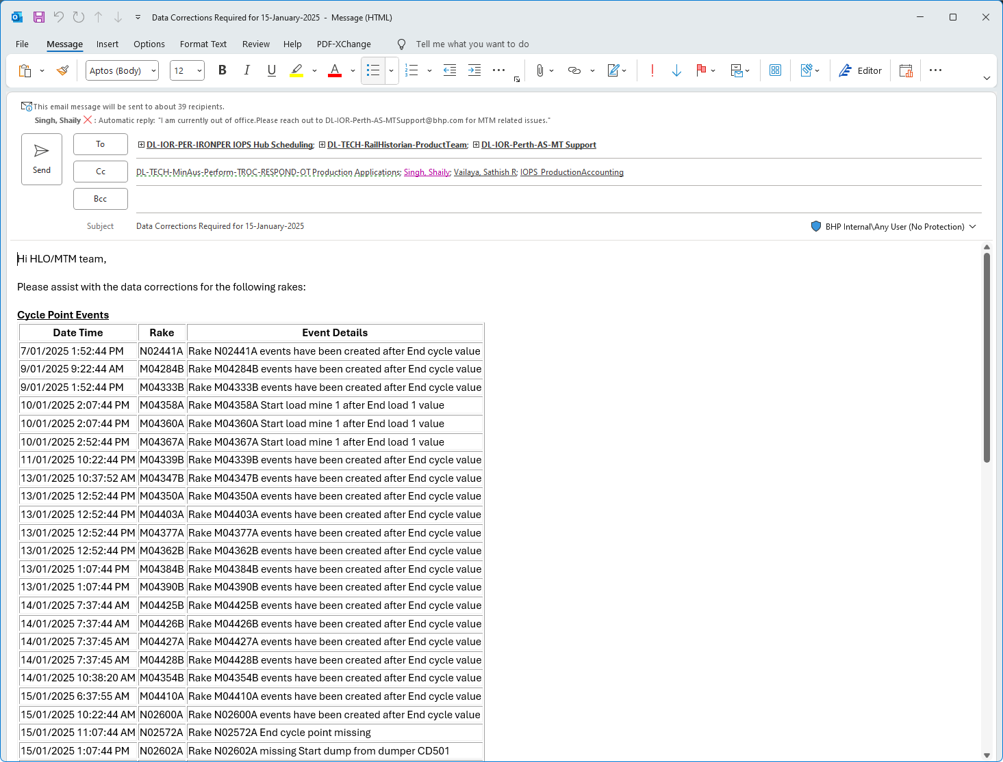
8. **Close the window** (*You can just press the X in the upper right corner*)  
   